Candidate Kelsey Escue |  | Field Supervisor Shari Densel
Date | September 6th, 2017 | Mentor Teacher Noralyn Sutherland

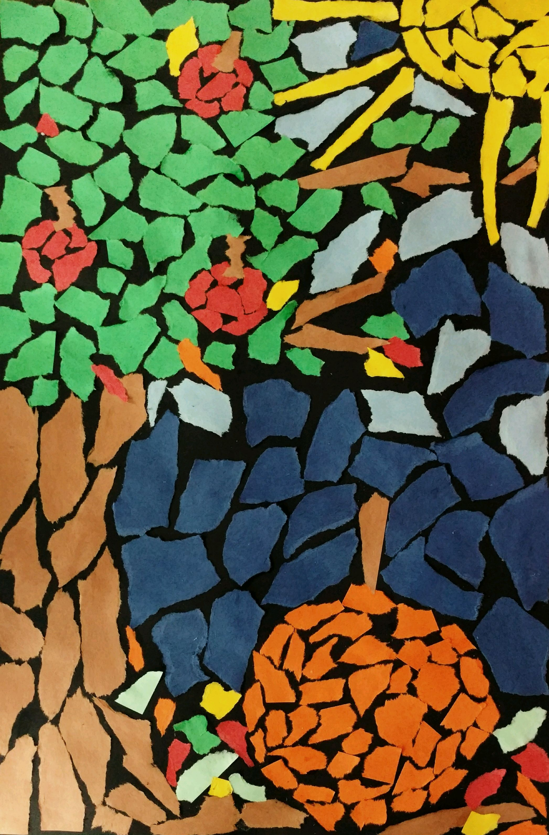
Unit/title: Mosaics
Grade level: 4th Grade
Number of Students: 28
Lesson ___1__ of __3___
Lesson title: Fall Ripped Paper Mosaics
Enduring Understanding
Students will compare and contrast what defines a mosaic, along with identifying and analyzing color relationships. Students will question what makes a successful mosaic, and describe their theme identifying the season Fall.

Rationale:
Through this lesson, students will physically, mentally, and creatively express a mosaic with ripped paper. Videos, interactive conversations and activities will expose students to another aspect of contemporary visual arts culture. Ripping numerous pieces of colored paper to create their puzzled mosaic teaches habits of the mind, including persistence and envisioning. Due to contemporary imagery’s versatility, students can challenge their craft and envisioning with multiple tints and shades of colors, along with focusing on color relationships (warm versus cool), and rip intricate pieces of paper to innovate in their mosaic.
Summary: In 3-5 sentences, answer the following questions:
- Students will interpret something they see, in the current season of Fall, into a ripped paper mosaic.
- Students will experiment with tints and shades of colored ripped paper while constructing a mosaic. Students will investigate what qualifies as a mosaic.
- This lesson is personalized due to every child’s individual interests in Fall; the student chooses their Fall content for their mosaic. Students will gain understanding of mosaics long historical context by looking at a video of Roman mosaics.
Lesson Objectives
The students will… | Lesson Objectives / Learning Targets | ODE  Code | Visual Arts Standard | Assessment/Evaluation  of evidence
1 | Students will work independently and persistently throughout the lesson | 4PR | Demonstrate motivation, independence and persistence during studio practices to complete artworks | Students complete the handout, sketch an idea for their mosaic, rip multiple colors of ripped paper (including tints and shades), glue those pieces to create their sketch of Fall.
2 | Students will experiment with ripping paper to create a mosaic that conveys beauty. | 2PR | Experiment with art materials by using them in unexpected and creative ways to express ideas and convey meaning. | Students choose something they admire from Fall to convey something beautiful into a mosaic with ripping paper.
3 | Students will rip different tints and shades of colors to construct their mosaic. | 5RE | Refer to criteria and use art vocabulary when discussing and judging the quality of artworks. | Students used tints and shades in their mosaic, along with identifying where they see mosaics in their world on their handout
4 | Students will create a mosaic that links to their interpretation of Fall beauty and admiration. | 5PR | Link ideas in and design of works of art to the emotions and moods expressed in them. | Students sketch and create a mosaic that depicts an emotion of passion.

Use bullet points and include a definition for each word using language that is appropriate to your students’ grade level.
Content vocabulary: Art-related words which are unique to this lesson.
Mosaic – a pattern or picture made up of small pieces of color.
Stain Glass – colored pieces of glass put together to create an artwork, uses mosaic.
Tint – a color with white added
Shade – a color with black added
Warm – reds, oranges, and yellows
Cool – blues, purples, and greens
General vocabulary:
The Romans – An early civilization that experimented with the first mosaics.
Fall – the season in the beginning of the school year.
Beauty – something that you admire and are passionate about
Toledo Museum of Art – local place to view art for free
Instructional terms:
Ripped Paper – ripping paper with a purpose in art to create a larger image
Gluing – a raindrop of glue for each piece of ripped paper
Artist Sketches – the ideas that come before the final or favorite result
Planned Assessments
Attach copies of any handouts that you will provide to students.
Pre-Assessment:
Interest survey class conversation about Mosaics and where they see them. Short question and answer session with students about what they know about color relationships, including tints and shades.
Formative Assessment
Verbally quiz over examples of tints and shades. Students complete handout with questions and a picture to color. Students give a thumb up throughout lesson as a check for understanding. Walk while observing students working on sketching and ripping paper – along with effort.
Summative Assessment
Students will participate in class discussion about their feelings and what they learned about the lesson (i.e. tints and shades, mosaic). Students will state one thing they liked, learned, and want to keep working on in a written response at the end of the lesson. Students will rip different tints and shades of colors to construct a mosaic (Objective 3).
Differentiated Instructional Strategies
Use bullet points.
Write out how your lessons will support different types of learners. Include:
- English language Repeat instructions, teacher sample, visuals in PowerPoint, subtitles in videos, and mosaic handout.
- Visual Offer demonstration of ripping, teacher sample, PowerPoint, Videos, artist images.
- Verbal Have students repeat instructions and key vocabulary words, students share what they are doing to their neighbors.
- Hearing-impaired present step by step demonstrations, have audio/visual recording of directions available
- Kinesthetic “activate” students during your instruction as helper, ripping paper
- Students with physical disabilities provide hand over hand instruction
Project extensions Students can challenge themselves by adding highlighting and shading to their mosaic with ripped paper. Student can also create a ripped paper frame for their piece.

Lesson Resources

Equipment: Mini projector, projector cord, computer, speakers, computer charger, chalk board.
Health & Safely: First Aid Kit
Supplies: Box of scraped colored and patterned paper, a class set of colored construction paper. Class set of the following: 12x18 black construction paper, glue bottles, pencils, stock paper, and crayons.
Instructional support materials: Teacher sample, PowerPoint, Videos, Handouts
LESSON PROCEDURES
 | Teacher actions  (What will you be doing?) | Student actions  (What will students be doing?)
Assessment of Prior Learning or  Pre-Assessment | Ask students to “have their butts in their seats, mouths zipped, and eyes on me”. Turn the lights off and have the PowerPoint ready.  Ask students what they think a mosaic is and lead into the PowerPoint | Students sit and listen to directions. Students raise their hand and guess what a mosaic is.
Lesson  Opening/  Introduction | Introduce what a mosaic is from the PowerPoint. Explain that a mosaic comes from the idea of beauty and to create something you admire. Show example of first mosaic: ask students what colors they see in the sky and what colors in the water. Identify the color relationships of warm and cool colors. Show student level mosaic. Show a mosaic example of pop culture reference, Beauty and the Beast stain glass window. Ask where they see stain glass? Point out: if you zoom in you only see shapes and colors, if we zoom out we see the picture.  Introduce tints and shades. Verbal quiz over examples in real life.  Ask the class if you want to use one color of red or tints and shades of the color?  Ask student where they see mosaics in their world? | Students listen and observe the example. Students raise hands and respond to the colors they see. Students Identify warm and cool colors.  Students identify stain glass windows.  Students identify tints and shades.  Students respond to the PowerPoint.
Allotted Time | (be approximate) 10 minutes
Formative Assessment/ | Verbally quiz over examples of tints and shades. If I eat strawberry ice cream is it a tint or shade? If I eat chili is it a tint or shade? Ask for examples of tints and shades. | Students answer and respond to questions.
Body of Lesson (studio activity) | Have students start brainstorming ideas for their mosaic.  Students watch a video on Early Roman Mosaics: https://www.youtube.com/watch?v=V7NvuCphsbY  Students watch cartoon that digs deeper into mosaics: https://www.youtube.com/watch?v=YjcEu_ssZTQ&t=227s  Indicate the ways that you will have students apply their own “voice” in this lesson. Students apply their own voice to the lesson through their visual interpretation of something beautiful in fall and their execution of ripping paper for a mosaic.  What is your favorite thing about fall?  What is beautiful to you this time of year? Ex. Pumpkins, pie, apple orchards, colored leaves, Halloween… | Students will watch video about historical Roman Mosaics.  Students will watch a cartoon penguin create a mosaic of a fish from teddy bears.  Students will decode what is beautiful and where they see beauty in fall. Students will pick an object to focus on for fall to create a mosaic.
Allotted Time | (be approximate) 15 minutes
Formative Assessment/ | Ask students for a thumb up to verify their understanding of mosaics | Students put a thumb up, sideways or down to confirm understanding
Lesson Closure | Remind students why the lesson is important & relevant to them: look for something they are passionate about or admire in fall.  Link students back to the Toledo Museum of Art and movies to see mosaics. Mention Beauty and the Beast.  Ask students to reflect on their favorite parts of fall.  Announce that students will start sketching next week and ripping their paper | Students make connections to the world around them. Students reflect on their favorite aspects of fall.
Allotted Time | (be approximate) 5 minutes
Formative Assessment/ | Verbally quiz students when lining up to leave art about what they will be doing next week- artist sketches for mosaic. Verbal quiz over tints and shades | Students raise hands and respond
Summative Assessment | Discourse over students feeling about the project to come: what to anticipate and the experimentation with ripping paper | Students process new information and translate it into their lives for the following week until the next class – hopefully coming with anticipation or questions.

