Food Collage Drawing
Advanced Drawing / 2nd Semester

You will compare and contrast what defines a collage, along with identifying and analyzing your portfolio theme and its relationship to food. You will question what makes a successful collage, and describe you theme identifying through food.

Through this lesson, you will physically, mentally, and creatively express a collage with magazines, printed photos, papers and other miscellaneous materials; after, you will produce a master drawing of the collage. Piecing together numerous objects from sources to create puzzled collages teaches habits of the mind, including persistence and envisioning. Due to contemporary imagery’s versatility, you can challenge your craft and envisioning with layering, along with focusing on graphite or charcoal tools, and cutting intricate pieces of paper to innovate in their collage.

You Will:
- Interpret something their theme with food, into a magazine paper collage.
- Experiment with layering in the collage and drawing on a smaller scale
- Investigate what qualifies as a collage

Materials:
- 12x12in collage paper, scissors, glue
- Magazines, Printed photos, construction paper, paint or marker, etc..
- 12x12in drawing paper
- Graphite pencil, charcoal pencil, sketch and wash

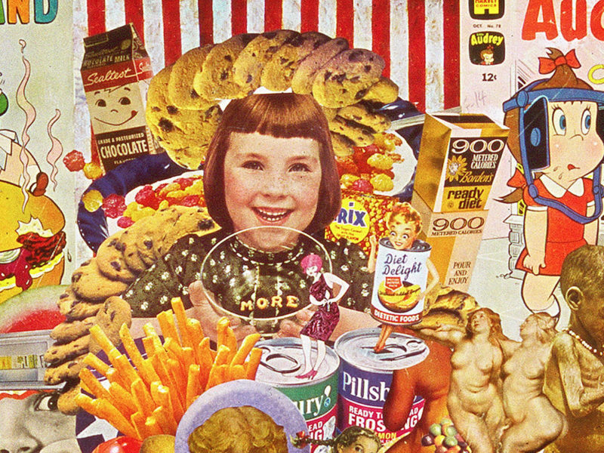
Points (250 points total)
Research 50 pts
Craftsmanship 100 pts
Time Management 100 pts

